2026 ART KAOHSIUNG Application Form
Fair Information
Public Days | 2026.3.21 - 2026.0.23 | VIP Preview | 2026.3.20 (Friday)
Venue | Shin Kong Mitsukoshi（Kaohsiung Zuoying）  No. 123, Dazhong 1st Rd., Zuoying Dist., Kaohsiung City 813 , Taiwan (R.O.C.)
Organizer | Formosa Art Fair Co., Ltd.  3F., No. 110, ChangChun Rd., ZhongShan Dist., Taipei City 104089 , Taiwan (R.O.C.)

Beneficiary Account
Bank Name | TAIPEI FUBON COMMERCIAL BANK
Bank Address | No. 152, Sec. 2, Xiyuan Rd., Wanhua Dist., Taipei City 108, Taiwan ( R.O.C )
Swift Code | TPBKTWTP
Beneficiary Name | Formosa Art Fair. Co., Ltd | Account No. | 8311-0000-550-453
Beneficiary’s Tel. | +886-2-2578-0259
Beneficiary’s Add. | 3F., No. 110, ChangChun Rd., ZhongShan Dist., Taipei City 104089 , Taiwan (R.O.C.)

Booth Wish Order | Section | Booth Number | Booth Quantity
1st Wish |  | -
2nd Wish |  | -
3rd Wish
Special Offer
10% discount of booth fee for the exhibitors of 2023 & 2024 ART KAOHSIUNG. |  |  | □ Yes □ No

I agree with all the rules in the application form and guideline and make a deposit of USD400 for application.

Gallery Name：
Authorized Signatory：
Date:

*Please use digital signature, or sign after printing out and attach the scanned file.
Gallery Information
Gallery Name (Please confirm upper/lower-case) |  |  | Gallery Name in Original language
City | Country |  | Year of Establish
Address |  |  |  | Postal/Zip Code
Instagram
Meta (Facebook)
EMAIL | Tel (E.g. +886 2 2578 0259) |  | Website
Director Name | Mobile |  | EMAIL
Contact Person Name | Mobile |  | EMAIL
Registered Company Name/Billing Name |  | VAT number
Billing Address |  | Tickets Sending Address/Leave in Counter

Galleries in other locations
Branch Name (please confirm uppercase/lowercase)
Address
EMAIL | Phone (E.g. 886 2 2578 0259)

Notice of Application
✓ | Check List
 | - Completed and signed Application Form
 | - Gallery Information
- Exhibition Records and Represented Artists
- Artwork image title format: "Artist name_Work Title__Year_Medium_Size ".
- File Format：Images with JPEG, 150-300dpi, size under 1MB. Video with MP3 or MP4.
 | - Bank slip of USD400 deposit transaction
Notice of Application
- Please submit the form and attach the images before the deadline.
- Please fill 3 booth-wish-orders according to wish. When the first order is full at the time of submitting, the second order will be arranged, and so on.
- Please confirm the content of the form is correct. The organizer has the rights to use the information and images for all printed matters and marketing material concerning the fair.
- The files are not refundable.
- Large files shall be sent by file transfer system or cloud system, such as wetransfer.com, dropbox.com or google drive.
- The remitter shall absorb the cost of commission fee in the transaction.
- The organizer will send the confirmation mail within 7 working days. Please contact us if you fail to receive it.
- The organizer has discretion to the exhibitor list.
- The organizer will notify the exhibitors of the rule of booth selection.
- The organizer reserves the right of execution of the event.
Application Method
Please submit by email to artkaohsiung@gmail.com with the subject "Gallery Name_2026 ART KAOHSIUNG Application" attached with the deposit USD400 payment slip/receipt at the same time.
Organizer
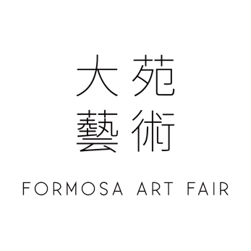
FORMOSA ART FAIR CO., LTD.
3F., No. 110, ChangChun Rd., ZhongShan Dist., Taipei City 104089 , Taiwan (R.O.C.)
VAT 45008490 T +886-2-25780259 F +886-2-25780219
E formosaartfair.co.ltd@gmail.com W www.art-formosa.com

Booth Types
Section | Booth size |  | Booth Quantity | Amount（USD）
Section A  10 Floor | 21.6 sqm  ( W 3.6 x L 6 x H 3.6 m ) |  | 22 | USD5400  Provide 5 nights of hotel accommodation
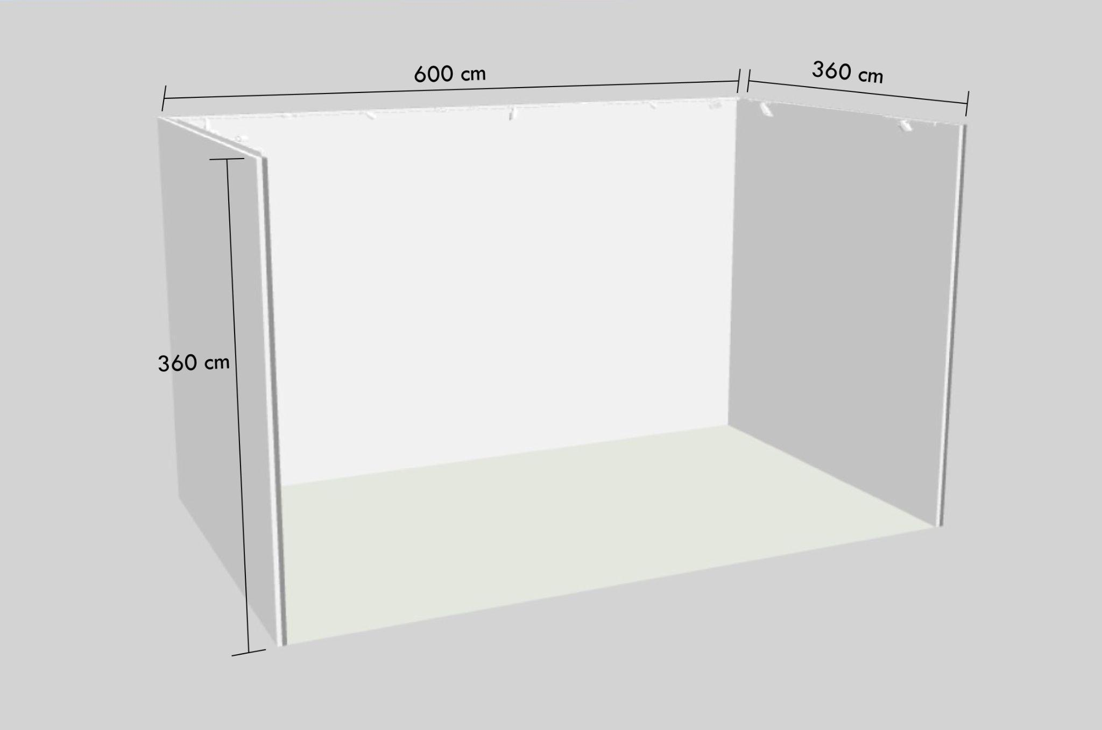 |  |  | 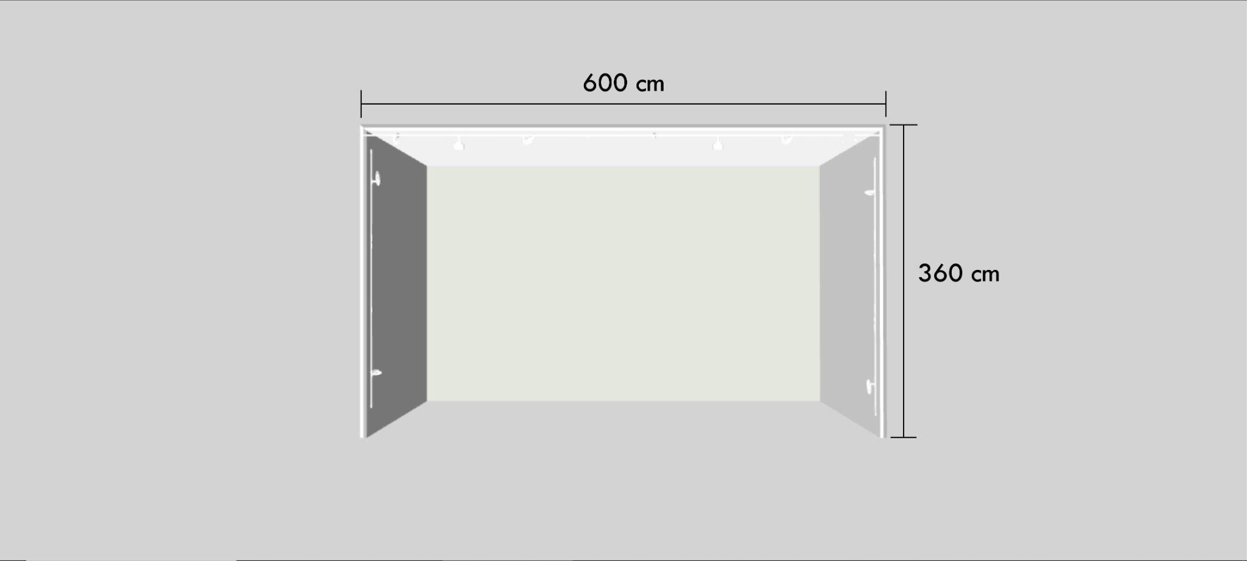
Section | Booth size |  | Booth Quantity | Amount（USD）
Section B  10 Floor | 15 sqm  ( W 3 x L 5 x H 3.6 m) |  | 20 | USD4000  Provide 5 nights of hotel accommodation
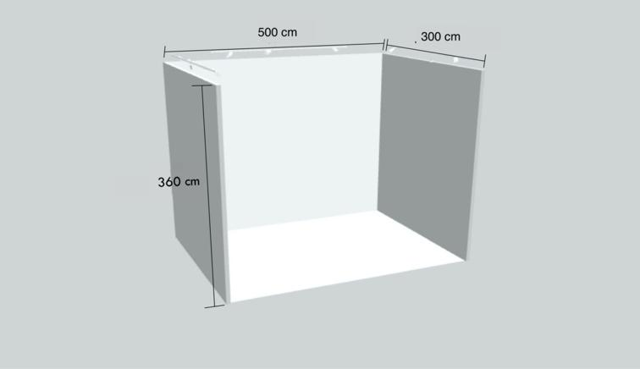 |  |  | 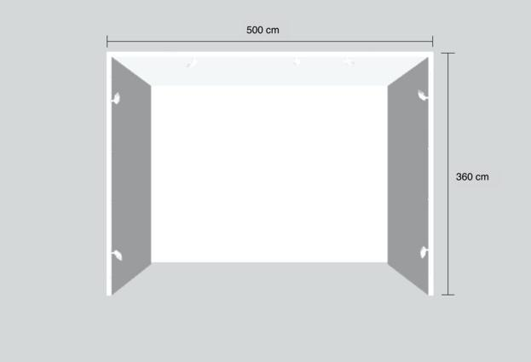
Section |  | Special Booth Size | Booth Quantity |  | Amount（USD）
Section C  11 Floor【Main Entrance】 |  | The Panel Height 2.4m | 5 |  | Price include 5 nights hotel accommodation
One spotlight is provided every 1.5 meters.  Note: Hooks are only permitted for use on the display panels in this area. |  |  |  |  | Price include 5 nights hotel accommodation
Booth No. : C-A1, with 7 spotlight |  |  | Panel Size 10.19m |  | 2,000
Booth No. : C-B1, with 12 spotlight |  |  | Panel Size 18.94m |  | 7,400
Booth No. : C-C1, with 10 spotlight |  |  | Panel Size 16.82m |  | 6,700
Booth No. : C-D1, with 18 spotlight |  |  | Panel Size 32.31m |  | 11,700
Booth No. : C-E1, with 12 spotlight |  |  | Panel Size 20.48m |  | 8,400
I. All prices above are without the 5% Value-added tax fee.
II. Priority for booth selection once the payment is completed.

Booth Items
- Section A Standard Booth 21.6 sqm：
- 11 Panels with 8 Spotlights.
-Each exhibitor orders 1 or 2 booths including 1 free specified hotel accommodation. If ordering 3 booths above, 2 accommodations will be provided.
- Each booth includes 20 collector cards, 20 VIP cards, 20 one day tickets, 4 exhibitor badges and 1 page of digital catalog.

- Section B Standard Booth 15 sqm
- 11 Panels and 6 Spotlights.
-Each exhibitor orders 1 or 2 booths including 1 free specified hotel accommodation. If ordering 4 booths above, 2 accommodations will be provided.
- Each booth includes 5 collector cards, 20 VIP cards, 20 one day tickets, 4 exhibitor badges and 1 page of digital catalog.

- Section C Booth, Panel Height 2.4m：
- 10 Panels and 7 Spotlights.
- Every 1.5 meters with one spotlight .
- Each booth includes 1 free specified hotel accommodation.
- Each booth includes 20 VIP cards, 20 one day tickets, 4 exhibitor badges.
- Each booth includes one page on the catalog with one artwork image.

Timeline
31 Dec 2025 (Fri) | Application Deadline & Deposit submission Deadline  1. Upon applying, the gallery should proceed with the deposit of USD400.  2. If the application is rejected, the deposit will be refunded.  3. In the case of the admitted gallery canceling the participation, the deposit is non-refundable.
Dec 2025- Jan 2026 | Application confirmation by email  The committee will email a confirmation reply after receiving the application form.  If you do not receive a confirmation reply within 7 working days after application, please kindly contact us at: art.kaohsiung@gmail.com
Mid Jan 2026 | Selection result notification  The organizer will notify the result of the review by email and send a payment request at the same time. After the exhibitor receives the participation confirmation letter, please pay the fee in full within 10 working days to confirm the participation qualification.
31 Jan 2026 (Sat) | Payment and Media Promotion Form Deadline  1. To assure all rights of participation, the gallery is obliged to make full payment.  2. The date of payment is according to the date noted on wire transfer receipt or check issue date.  3. In the case of failure to pay on time, the admitted gallery will be disqualified.

Exhibition Schedule
19 March 2026 (Thu) 12:00 – 20:00 | Installation
20 March 2026 (Fri) 08:00 – 12:00 | Installation
20 March 2026 (Fri) 12:00 – 20:00 | Collector Preview
20 March 2026 (Fri) 15:00 – 20:00 | VIP Preview
20 March 2026 (Fri) 18:00 – 20:00 | Vernissage Night
21 March 2026 (Sat) 11:00 – 19:00 | Public Day
22 March 2026 (Sun) 11:00 – 19:00 | Public Day
23 March 2026 (Mon) 11:00 – 19:00 | Public Day
23 March 2026 (Mon) 19:00 – 22:00 | Deinstallation
24 March 2026 (Tue) 08:00 – 12:00 | Deinstallation
Exhibition Records and Represented Artists
Latest 3 - 6 Exhibitions in gallery and art fairs
No. | Exhibition Name | Duration (DD/MM/YYYY)
1
2
3
4
5
6

3 exhibiting artists with CVs and 3 work images for each artist at most (Revisable)
1 | Artist Name |  | Nationality |  | Year of Birth
1 | Artist brief introduction 200 words
1 | Art Work image I |  | Artwork details | Title_Year _Medium _Size
1 | Art Work image II |  | Artwork details | Title_Year _Medium _Size
1 | Art Work image III |  | Artwork details | Title_Year _Medium _Size
2 | Artist Name |  | Nationality |  | Year of Birth
2 | Artist brief introduction 200 words
2 | I. Art Work image |  | Media
2 | II. Work Title |  | Media
2 | III. Work Title |  | Media
3 | Artist Name |  | Nationality |  | Year of Birth
3 | Artist brief introduction 200 words
3 | I. Work Title |  | Media
3 | II. Work Title |  | Media
3 | III. Work Title |  | Media

